**UML Database Diagrams**

**for the**

**SIUE Department of Computer Science**

**CS425 / CS499 Senior Project**

**Software Design and Implementation Courses**

**by**

**Zach Benchley, Matt Lievens, Logan Maughan, Brian Olsen**

**of**



**Learning Outcomes-Based Assessment Database Team**

Revision 1.0

As Of: December 3, 2013

Change Log:

|  |  |
| --- | --- |
| Revision | Change Note(s) |
|  |  |
| 1.0 | * Initial Release |

Reviewed and Approved By:

Name Signature Date

# List of Figures

Figure 1 – ER Diagram 4

Figure 2 – ER Diagram 5



Figure 1 – ER Diagram

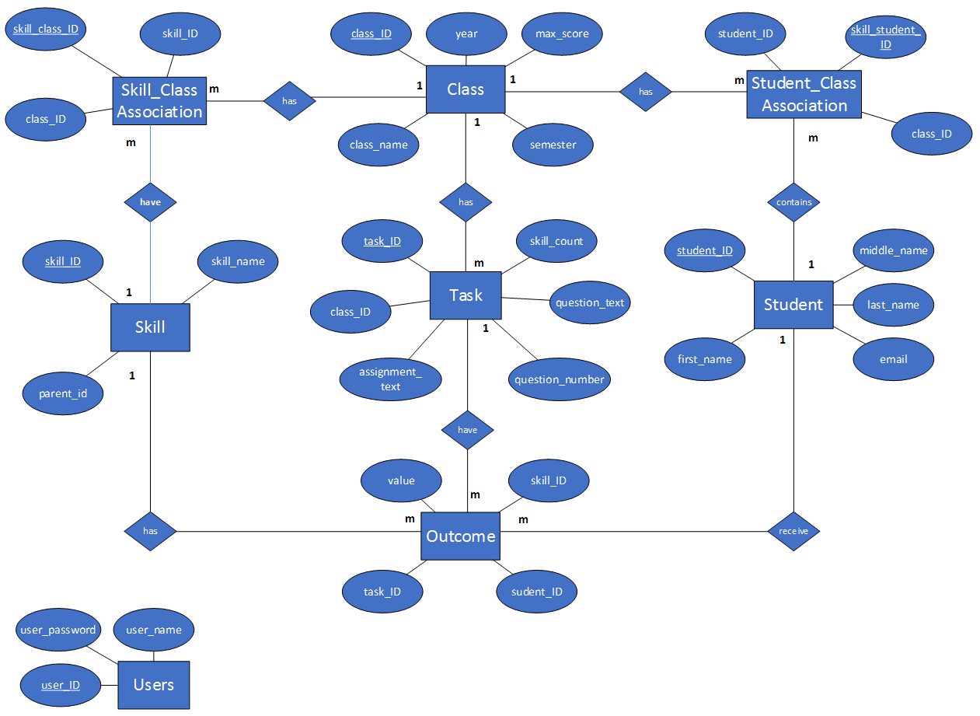

Figure 2 – ER Diagram